exercise 6;
- SELECT * FROM employee_data ORDER BY salary ASC;
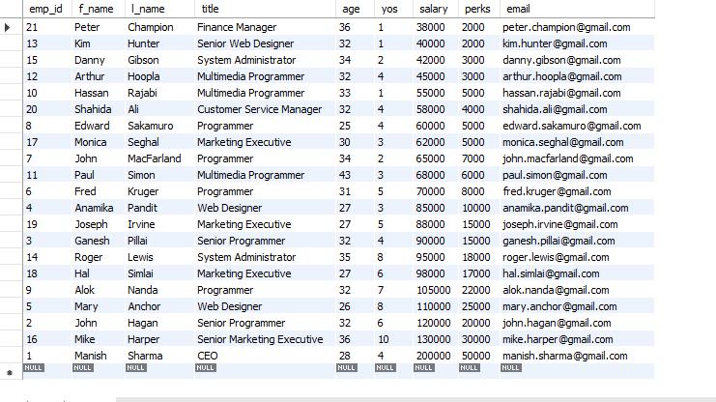
- SELECT * FROM employee_data ORDER BY yos DESC;
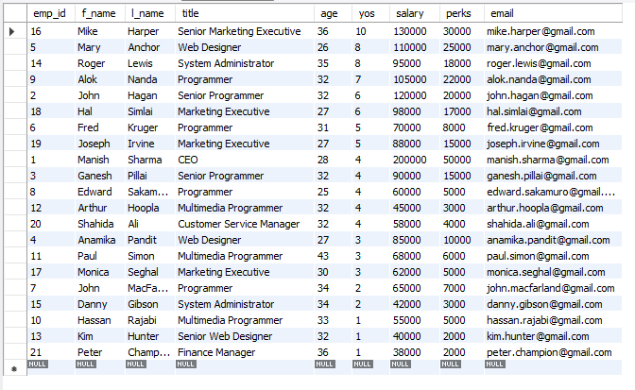
- 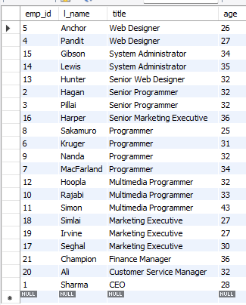
- SELECT CONCAT(l_name, ' ', f_name) AS full_name FROM employee_data WHERE title IN ('Programmer', 'Web Designer') ORDER BY l_name ASC;


